Fourth Grade Supply List
Mrs. Thompson
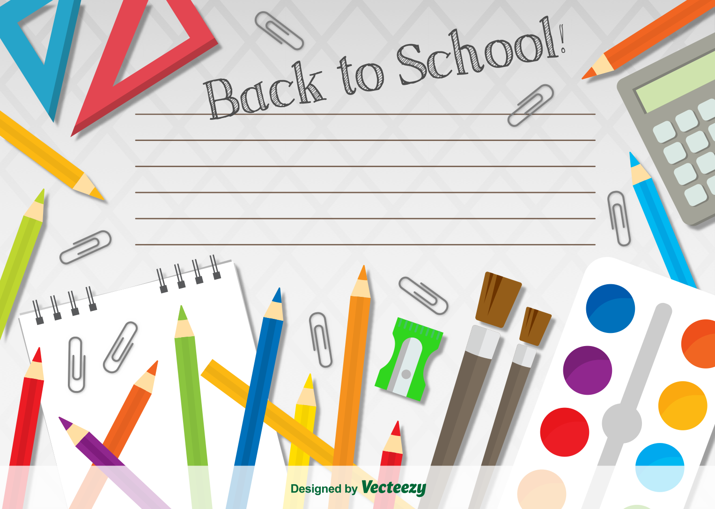
Welcome to fourth grade! I am excited for a great year.
Thank you for sending the supplies ready to be used on the first day of school.
The items on this list will be used during the regular school day. They may be brought from home on a voluntary basis. Otherwise, they will be furnished by the school.
Extra supplies are greatly appreciated.
- backpack
- flat pencil bag with a zipper (not a pencil box)
- sharpened pencils
- small pencil sharpener with an enclosed bottom
- erasers (pink and/or pencil tops)
- glue sticks (no glue bottles)
- crayons (24 ct. or smaller)/Twistables are great
- colored pencils (no markers, please)
- scissors
- 1 spiral-bound 8 ½ x 11 notebook (one subject)
- water bottle with a pop-top/sport lid that stays on for drinking (sent filled each day)
- sturdy earbuds or headphones to use with Chromebooks
- a chapter book to read until we go to the library
Please send the above items removed from their packages and ready to be transferred directly from your child’s backpack into his/her personal desk tote on the first day of school. Thanks!
Optional, but appreciated (for the classroom to share):
- Kleenex
- paper towels
- Clorox wipes
- liquid soap (regular size with a pump) and hand sanitizer (regular size with a pump)
I understand wanting to use refillable dispensers, but they get too “germy” at school.
😊

